

**BUSINESS CASE**

**Find-A-Spot App**

**California State University Los Angeles**

**School of Business & Economics**

**Business Project-IT-Enabled**

Beza Gidey

Sebastian Kouladjian

Lara Hasan Mutal

Sultan Zahid

Ruben Llanos

Raymond Delgado

Harut Sepetjyan

Alexis Gonzalez

**Table of Contents**

1. Executive Summary
   1. Mission
   2. Issue
2. Problem Definition
   1. Problem statement
   2. Alternatives available
   3. Summary of Preferred Alternative & SWOT Analysis
3. Recommended action
   1. Organizational Impact
   2. Impact on University mission and other services
   3. Risks
4. Project Overview: A plan for the transformation
   1. Goals and objectives of transformation
   2. Success metrics
   3. Major Project Milestones
5. Cost Benefit Analysis
   1. Impacts on revenue
   2. Impacts on costs
   3. Comparisons with alternatives
6. Application Prototype
   1. Admin login vs user login
   2. Database
   3. Technology Migration Plan

Introduction

This paper presents the generic concept of using cloud-based car parking locator for campus University’s, as an important application deployed on the Find-A-Spot (FaS). The corresponding FaS profile includes input layer, communication layer, and application layer. We will outline areas which build a step by step process that demonstrates provision of parking efficiently within a University campus along with details of its design and implementation.

1. **Executive Summary**

California State Los Angeles University’s campus (CSULA), a lot of students and faculty often find themselves struggling to find parking on campus. Sometimes this dilemma will cause students to be late to class or even miss the class. Our purpose as a company is to create an application that aids in the finding of parking spots on both the students and facility while ensuring safety.

In our plan for FaS, the app will be available on both Android and iOS devices. The function of the app will most basically be to have a live updated map of parking spots on campus that a user can view. The way these maps will be updated will be through possible systems of cameras, drones, or sensors which scan barcodes of vacant spots and update the map accordingly. Our app will also include a feature which shows the best place to park on any given day or time based on data collected that shows how many people are going in and out of lots, how long they are staying, and how many empty spots there are in that lot on average.

Through the live updating of a campus parking map, Find A Spot will seek to fulfill the parking needs of students, faculty, and visitors to CSULA. Our app customers will experience parking with ease while also feeling as if their cars are a little safer parking in our monitored lots. Our values as a company are to ensure safety while creating the best and easiest experience for our users.

1. Mission

Find-A-Spot’s mission is to create efficiency, convenient, stress-free parking environments on campus. We will deliver an app developer in order to ensure a well put together experience for our users. We will also purchase top of the line drones in order to have a good visual reference in order to update the live maps. We will not need a lot of employees, but we will have people to fly the drones, help with technical issues both on the user and developer side, and also make sure our core values are clear by expressing maximum deliverance to our end users with up to date reliability with our product.

1. Issue

The problem situation arises when there is no handheld application to provide information on availability of space for parking a vehicle in the CSULA parking lot. Such an application would be able to constantly update with the latest information about parking space availability. For that reason, we planned to design an application on the top selling smartphone platform, Android and IOS. The Alternative solution is to create a real-time map for parking app, which will help provide information on available spaces on campus.

**2. Problem Definition**

* 1. Problem Statement

Parking spaces at Cal State LA fill quickly as a result of the high number of cars that arrive daily. According to the CSULA homepage 32,500 parking permits are sold each year. Yet the campus has just 7,370 available parking spaces, which means there is one parking space for approximately every four people on campus.

The Cal State LA parking lots are used by students, faculty, and staff and most of them drive their own car to campus each day. Mornings before 9 am can be crowded, but normally one is still able to find a space. However, later in the day drivers can see long lines of cars around campus, which further contributes to student and faculty tardiness and absenteeism. We have seen a lot of people who are actually willing to pay money to other students and staff to get their spaces. Furthermore, we have asked many students how long it usually takes to find a space and the answer was shocking because the average amount of time spent per day is 1.2 hours and could sometimes soar to about 2 or more hours during peak times.

* 1. Alternatives Available

There will be competition in the marketplace that will try to take some of our students from buying our parking pass and application. Some of our main competitors would be:

· *Metropolitan Transportation Authority (Metro) and Foothill transit*. The most common way most students commute to school is still taking the bus to school. There are close to 20 bus lines that serve the CSULA campus. The local and express bus lines offer discounts to students who use it monthly. Also there are several community-based shuttle that serve the across campus. However; it does not run in the evenings which perpetuates the parking problem.

· *Train*. There are a lot of students who prefer to take the bus to school. They travel from as far as Riverside County to come to CSULA; as in one of my classmates who does this on a regular basis. It is mostly low income students who prefer to take the bus because they cannot afford to buy a car. The price is $1.75 per drive; and the monthly bus pass is about $40.00. However; there are some serious disadvantages to taking the bus. Such as overcrowded buses which get very uncomfortable and also long delays waiting for arrival of the buses. Also people have to be dependent on certain operating hours since the bus only runs at certain times which are an inconvenience for most people who go to school or work at certain hours and use public transportation.

· *Uber/Lyft*. These applications work like having a private chauffeur who is requested and comes to pick the requestor off from the destination of choice and drops them off to the location of their choice for a charge of some dollars. This application is used by some of the students at CSULA who live nearby CSULA and want to spend a minimum of $1-$18 dollars to commute to CSULA with Uber X the cheapest service that it offers. The main disadvantage of these services is that they can get a bit expensive on a day to day basis if the commuter is coming from a far city. Uber is also very popular in the University of California, where it is possible for USC students to take Uber across campus for free. So Uber is growing more and more popular across the student body. There are also a low percentage of the student bodies who take the bicycle to school in comparison to students who drive a car to school.

· *Park Me*. This is an application that guides with finding open parking spots across the city of Los Angeles. So the map opens up the free spots and patrons can reserve a spot on the application in the city. At our campus the closest parking lot is at “201 Centre Plaza Drive Monterey Park,” which is a very small amount of parking spots for students. Also this application does not hold any features to regulate the parking system at the University level. In addition the parking spots are overpriced in comparison to daily meters or a day parking spots.

· *Metrolink.*  CSULA is the only university in Southern California to have a train station right next to the campus, which is very important for people living in the suburbs who want easier commuting to campus. The Metrolink that serves CSULA is the San Bernardino line with stations in San Bernardino, Rialto, Fontana, Rancho Cucamonga, and etc. cities across that side of town. Current students receive a 25% discount on monthly passes. However, it only runs until 10 pm which is a serious problem for some students that want to take advantage of library hours or work late.

· *Carpooling* is also another option for employees and student workers who want to receive free and preferred parking on campus. And, employees who bring children to a licensed childcare facility within one mile from the campus may also be eligible for carpool parking (this is only for the faculty which works on campus).

* 1. Summary of Preferred Alternative

Our product brings more value to the consumer because it makes the way to school easy. The application offers the possibility to go around stressful waiting times before the University and displeasing bus rides with crowded busses. The acquisition is for free and the monthly usage of the app is very low priced. Safe and stress-free arriving is the motto for this application, and that is what we promise to the users. Also it is very easy to use the application.

**SWOT Analysis:**

| **Strengths**  - It is more convenient for people to use  - The parking app save time when using and prevent waiting lines before parking lots  - People pay cashless with paypal or credit card, this will also save the labor force of collecting the quarters in the meter machine  - The need for a parking space will be solved efficiently  - Fuel Efficiency  - Affordable price and Innovative | **Weaknesses**  - The university has to invest in technology to use the features in the application  - Everybody has to have the app, otherwise not every feature can be used  - Limited parking spots |
| --- | --- |
| **Opportunities**  - Creating a department of parking office need to hire more students to control the parking app on computers  - The parking app may provide people to park in some area for free and they can take the bus for free  - Students who get excellent grade may get some advantage of parking price  - Decrease of air pollution because of shorter waiting times  - Work together with shuttle service from other parking slots  - Spread out to diverse Universities | **Threats**  - Visitors don’t accept the parking app  - Increase of the number of cars at the university  - Consumers’ use of alternative forms of transportation (bike, bus, etc.)  - School does not have much budget  - Students or staff might be confused with new parking rules  - Overpriced parking permits  - New apps which use the same technology |

**Marketing Plan:**

Product Strategy:

The CSULA Parking application is very similar in structure to the Uber application. Tap open the application and it displays a map in the middle of the campus as shown earlier in the introduction part of the paper. The green spots tell you that there are open spots that are available. On the right hand side there will be the main button one can tap in to look at the options that the application provides. The different drop downs will help the application user to navigate around it. There will be a payment page where one has their credit card information saved on. It will show the history of the purchases of the applications and permits. Next tab will be the discount for excellent students who have strong grade point averages. Below that application will be notifications which the user can allow or disallow. Furthermore, there will be a guidance tab and also a settings tab that will enable the student some help if they have trouble using the applications. And lastly there will be a “About” page that shows rating options for the application or the ability to follow the application on other social media outlets such as Twitter, Instagram, Facebook and etc.

Place Strategy:

The application can be purchased on ITunes, Google play store, and the Windows store for smartphones, computers, and tablets. This is only going to be implemented in CSULA first and then maybe across other schools. You can download the app on the school website as well.

Promotion Strategy:

We will promote this product by having it heavily advertised in our school newspapers and by sending the student, teachers, and faculty emails to their school email. During orientation we can make a quick little video demonstrating the problem with parking in our school. We can show a student downloading the application then being able to reserve a parking spot from home. As the student wakes up from bed, he reserves a parking spot before he does anything else, which saves him a lot of time instead of searching for a parking spot on campus.

Other strategies include:

· School websites/apps - Have big ads that get the attention of the person visiting these pages.

· School emails - Email a letter stating a change is coming to CSULA parking.

· Moodle site - Have it as a banner.

· Surrounding bus stops - Display a huge poster in the bus stops.

· Campus newspaper - Have a page strictly for the school parking explaining the changes coming.

· Word of mouth - Keep the talk active among classmates and friends on campus.

Pricing Strategy:

Normally the application costs around $4.99.

1) Students who buy the parking permit get the application for free.

2) Visitors can go to kiosk to buy $5 half day or $8 for full day passes.

3) Visitor/Student no parking pass. They can buy application and they get a discount for the parking pass half day $2 or full day for $5.

**3. Recommended Action**

1. Organizational Impact

CSULA is a home for more than twenty thousand daily commuters. As mentioned before, it is the only university that has its own metrolink station. The university provides several community base shuttle services, transit passes, discounted off site parking spots, ride share services and several alternative transport programs to solve the continuous parking issue in the university. But even with these alternative solutions and programs, finding a parking spot continues to have its issues. Especially during the morning hours most students circle around twenty to forty minutes to find parking spots. In the first two weeks of each semester the struggle is even greater. Some students are discouraged and dropped their classes because they were not able to find parking or others dropped by the professors because they were not able to attend the first class. Sometime students miss or arriving late to classes. Not to mention the parking wars in between students venting their frustration. This issue is not only affecting student academic performance and their well being but also the university enrollment system and graduation rates. In the long term, these parking issues will damage CSULA’s reputation and revenue. At CSULA parking innovations is needed more than ever and that is why we created Find-A-Spot app to help reduce wait/waste of time, traffic and energy. It offers the best alternatives, easy, fast, and eco friendly. At the same time it has potential to increase student enrollment, increase student academic performance, create efficiency, gives convenience, offers stress-free parking on campus.

1. Impact on University Mission and Other Services

CSULA parking facility is one of the university institutional service. It is one of the factors that can affect academic achievement. Find-A-Spot app enhance the quality of student school experience by providing safe parking facility and provide a support to CSULA’s main value “Students First “ allowing students academic success and well-being. With so many things to think of, parking shouldn’t be one of them causing stress and anxiety. Find-A-Spot app will provide easy parking that will be available to students, faculty members and administrators. The great part about this app is some departments are less busy than others which allow students to see where there is available parking. So, if they have to pick another parking lot just to save time at least they will have an opportunity to see what spaces are available before taking chances driving around campus looking for empty spots. This will add to academic success, reduce stress and motivate student to move forward worry-free. It will also allow higher attendance in classes due to lack of available parking spaces.

1. Risks

Find-A-Spot app is an integrated parking information, that is updated based on users input. There can be an issue with accuracy based on whether the user updates their space timely. This will create a false sense of reliability if someone forgets to mark the pace vacant. Timing is another factor which can be a problem with that is it’s accurate only for a minute or two at best, before someone else grabs the spot in which additional driving requires to find the next available spot . Consequently, it lead to additional driving and consume some time.

**4. Project Overview: A plan for the transformation**

1. Goals and Objectives of Transformation

Our primary goal of this project is to establish an application designed to efficiently and conveniently allow students and employees of Cal State LA to find a parking space on campus with the flick of a finger on their cell phones/internet devices.

It will allow students/staff to find available parking spots on campus, nearest parking lot to their assigned classes. It will save time and hassle to find parking, making it easier and efficient for students to get to class on time.

Further on this app could be used by the Parking Enforcement and Campus Administration to calculate total usage of parking spots and at what times. Administration could use this App to predict the high/low times for parking spots being used. This App could improve the rate of students buying parking permits as it would be easy to implement the App and Permits. It would improve the forecasting additional parking spaces needed and allowance for students to purchase daily passes and permits.

b. Success Metrics

One success metric would be customer satisfaction, which would be measured by users’ feedback. If a large percentage of users respond positively, then that would show how well-designed and efficient the application is, which would make the project considered successful. Another success metric would be the actual number of users of the app. In order to have a high percentage of users using the Find-A-Spot app, we would need to advertise it and give them incentives in order to convince students and employees to utilize it. The app itself would not be as efficient without there being a large percentage of users, since it relies on these exact users to provide data for the app, such as which parking spots are already taken. Another possible success metric would be overall academic performance by students. Since using the app would lead to a greater amount of students saving time by being able to quickly locate a parking spot, it would lead to much less overall stress and better in-class performance. It would also lead to better attendance rates, since less students would be late or absent to class.If there is a notable increase in student performance and attendance, that would mean the Find-A-Spot app was successful in accomplishing one of its goals. A fourth success metric would be the net income/profit ratio. Since Find-A-Spot would have many costs, including server infrastructure, maintenance, drones, etc., we would need to make sure we make enough profit to maintain the whole system.

c. Major Project Milestones

* Approval

This would involve making and presenting a proposal that outlines the development plan and a request for funding from the University’s Board of Trustees to get the approval to implement such an App.

* App development

Once it is approved, working on the development of the App will commence. The app would be developed to be user friendly and easily accessible to the students/staff and all end users.

* Transfer of Admin

Once the App is created and implemented it would be transferred to the

Parking Enforcement head to use and operate according to the need.

* Student/Staff access

After transfer of admin, the App would be available to the staff/students to have access and use to find parking spots.

* Feedback

Once the App is ready and running, the Admin will need feedback about the features and how user friendly it is. There is a chance that slight changes be made after positive or negative feedback of the end users.

**Cost Structure**

· Mobile Application Development – The development and maintenance of the mobile application requires hiring software and hardware developers as they will be the one responsible for the long-term success of the product.

· Mobile Application Database – The mobile application needs to subscribe to cloud database in order to store the mobile application’s real-time database

· Marketing – This includes advertising and promoting the mobile application to other distributing platforms.

Our Find-A-Spot app will be inexpensive as we will have collaboration with California State University, Los Angeles IT department and Engineering department. As shown in Table 1, the total for the app to launch will be approximately $144,050. This is based on 7,370 parking spaces that CSULA currently has available. According to the Los Angeles times, CSULA sells approximately 9,200 parking passes each semester.

|  | **Item** | **Cost** |
| --- | --- | --- |
| 1 | Cost of App Development | $ 72,800 |
| 2 | Drone with Camera | $ 1,400 |
| 3 | Backend System | $ 250 |
| 4 | Mobile Application Database | $ 45,000 |
| 5 | Marketing | $ 25,000 |
|  | Total | $ 144,050 |

·**Mobile application:**The mobile application acts like an interface for the end users to interact with the system. The application is developed using Javascript as a programming language. The purpose is to create applications that can run on both android and iOS platform with the same

source code. The purpose of this mobile application is to provide information regarding availability of parking spaces and allowing the end user to book a slot accordingly.

**Break Even Point**

Break-even point = Fixed cost/ total revenue- cost to make product

Our break even analysis will conclude with a 3.34 semester duration of selling 9,200 parking permits in order to pay itself off. The additional $5 per parking permit divided by our cost of production equals 30,730 then we divided this by 9,200 which gives us 3.34 time to breakeven. We will assume that there will be higher demand for parking permits however these assumptions are based on current figures which can reflect a minimum time for this project to find its feasibility. Thus, this project will be paid off within a year of its life cycle.

Moving forward, each year there will be $70,250 per year of operational cost after the first year. Our breakeven point after the first year will be 1 full semester of parking permit purchases.

**Product Strategy**

We will be discussing product implementation and usage as follows... FoS application is very similar in structure to the Waze app used to find better routes for getting to your destination faster. Our features will be to tap to open which will display a designated map (blue print) of its facility. We have provided you with CSULA parking map below (Please, see image 1). Here you will find available spots in green then when spaces are not available they will appear in red labeled as occupied. These color distinctions will display This app will only be available to students or facility who purchase parking permits. To ensure value added, we will be proposing an additional $5 fee added to the base permit cost as a “convenience fee.” This will offset capital cost by developing this application. We hope to capture a bigger audience by promoting permit purchases. The user will receive a promo code and downloadable link. Once the user has installed the app onto their desktop or mobile device, they will be able to register their permit to validate their credentials and begin using this new application. CSULA can provide services to potentially approximately 20,500 student and employs 2,100 faculty and staff giving a total of 22,600 people to target. (1) We believe 3/4 of this population will use this application which is approximately 16,950 users who drive to school, parking becomes competitive since CSULA only offers 7,370 parking spaces. Thus, purchasing parking permits with this application will allow these user to gain advantage over non-users. Furthermore, we anticipate during Spring and Fall Semester students will pay $205 for each parking permit. Based on our potential target audience in addition to increased student permit purchases the additional $5 fee multiplied by our Target users is $84,750 per semester given us a total of $254,250 per year of additional revenue.

Once the registration process is complete, the user has downloaded their application. They can know select any region highlighted on campus to view availability in each parking lots in groups of regions. Parking lots will be colored as green if the lot is occupied less than 75% full, yellow will be displayed if the lot is occupied 75%–89% full, and Red when there is limited space of 90% occupied (Image 1).

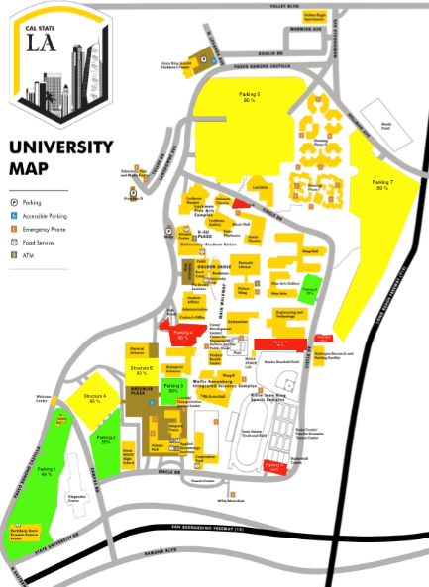

The user-intuitive interface will allow its users to swipe around the map to compare parking lots (Image 2).

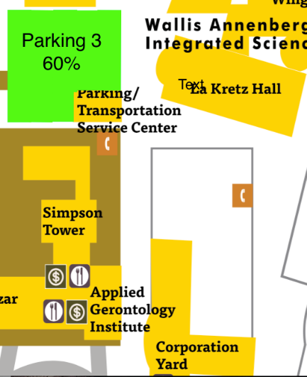

Once a desired parking lot is found, the driver taps the parking lot to view its availability percentage (Image 3).

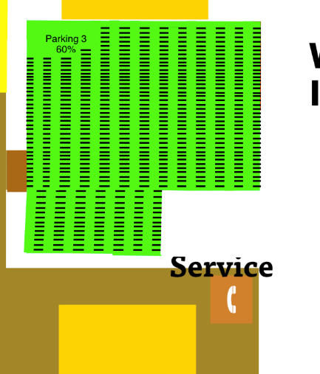

Furthermore, we’ve chosen lot 3 as an example as it is near our Business program closest to the Simpson Tower. As you will notice we have close to 60% capacity. Score! Business usually is more populated with students and staff in evenings rather than day. However, we wanted to display how 60% occupied shows on this application. We can double tap on this section to see in better detail of which available spaces are shown in green and spaces that are not available will appear in red (Image 4). Handicapped spaces are shown in blue, if they are occupied they will be shown in black.





**6. Application Prototype**

The Application home page will allow people to sign in as either a user or administrator. Administrative access allows product development where we started our development of software and hardware of the mobile application. For the software part of the mobile application, designing, programming, testing, and debugging are done. On the hardware side of the product, the development and testing of the device are implemented via smart phones such as Android and IOS devices. Meanwhile, customer service begins with after we release the product and the user has ran through its functionality, providing customer service feedback so that any initial errors or problems of the users are addressed early. We then maintenance and upgrading of the product by ensuring that every functionality and feature of the product is operating properly and referring to the problems and suggestions of the users.

User will have it’s own restricted access where after performing all the processes mentioned above, they provide feedback by clicking on the feedback button in the application. Here is a snapshot of our homepage of the application as follows...

Screenshot 01--App Home Page:

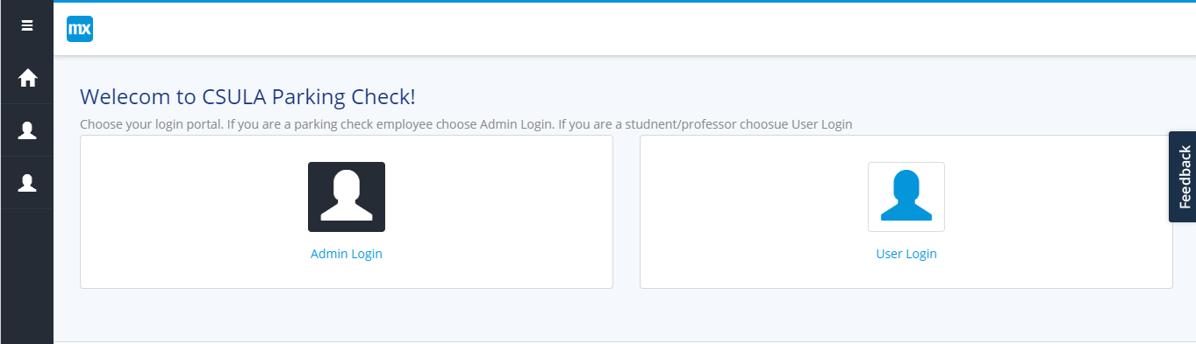

Here you will find the User Login...

Screenshot 02--User Login:

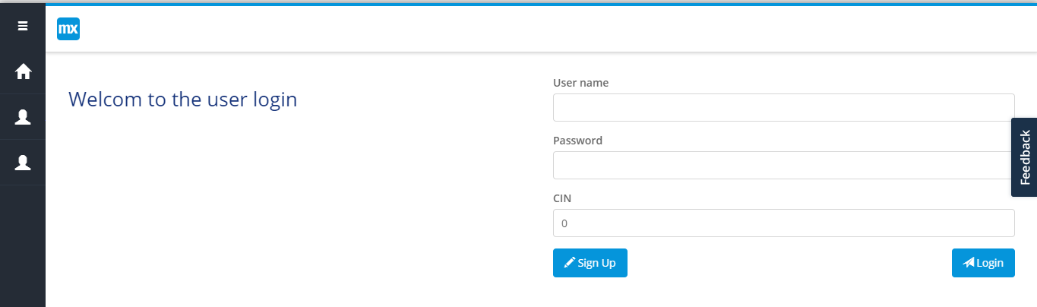

Screenshot 03--User Sign Up Page (Need to add header)

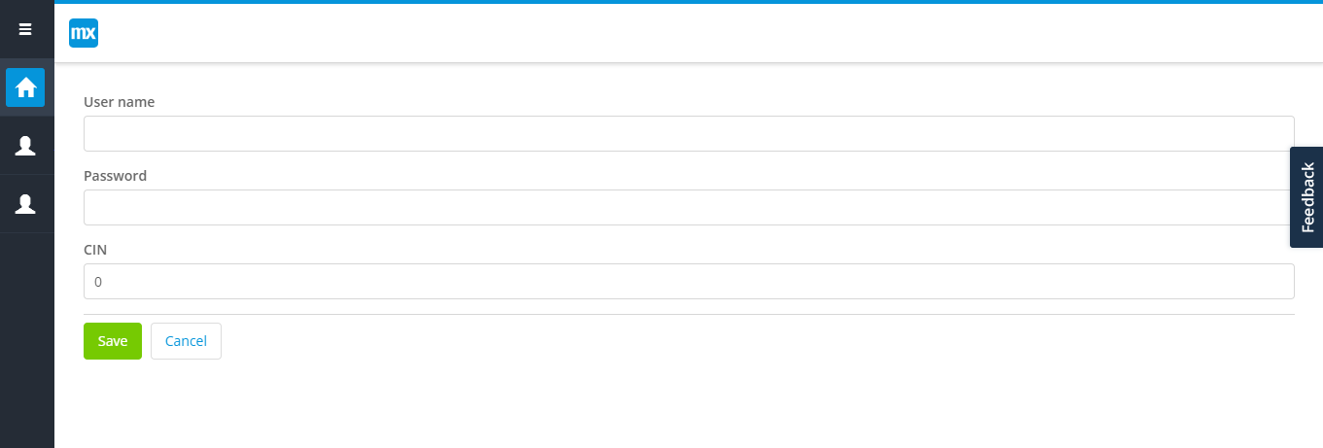

Here you will find the User hub...

Screenshot 04--User Hub Page (Need to improve layout)

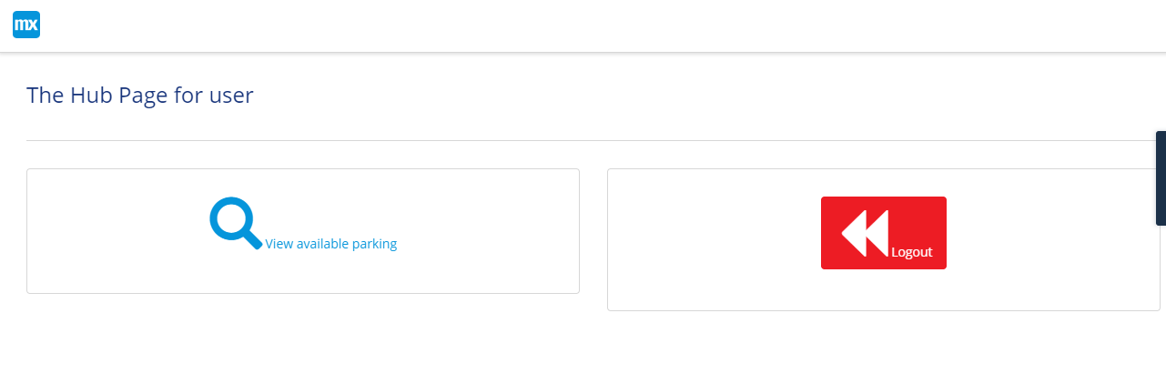

Screenshot 05--Parking View User, Map (Need to make the map work)

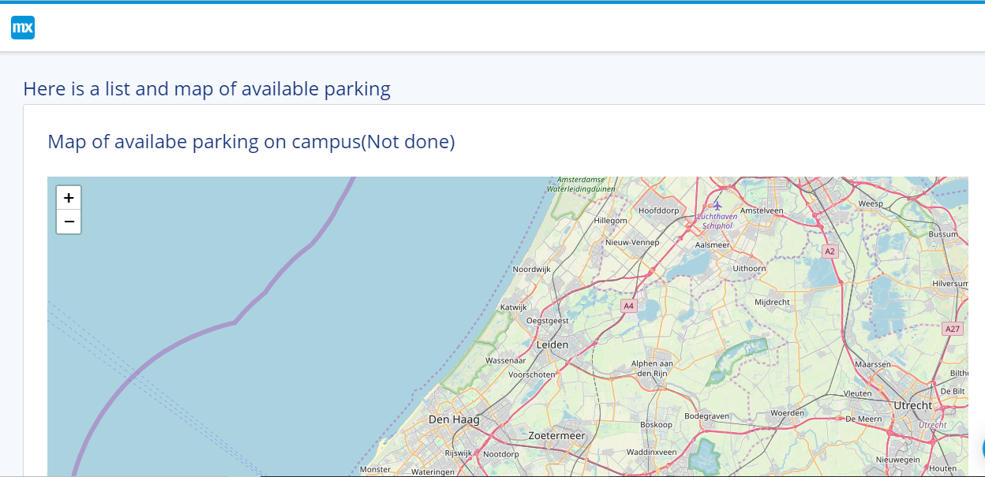

Here you will find the Admin login...

Screenshot 06--Admin Login

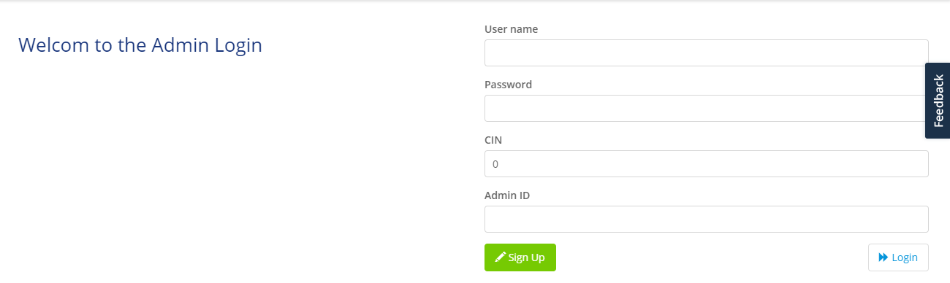

Screenshot 07--Admin Sign Up (Need to add header)

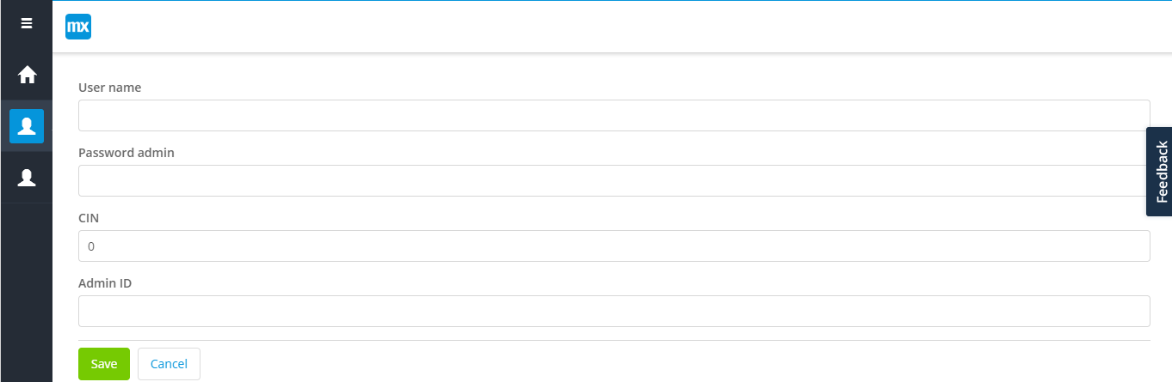

Screenshot 08--Admin Hub Page

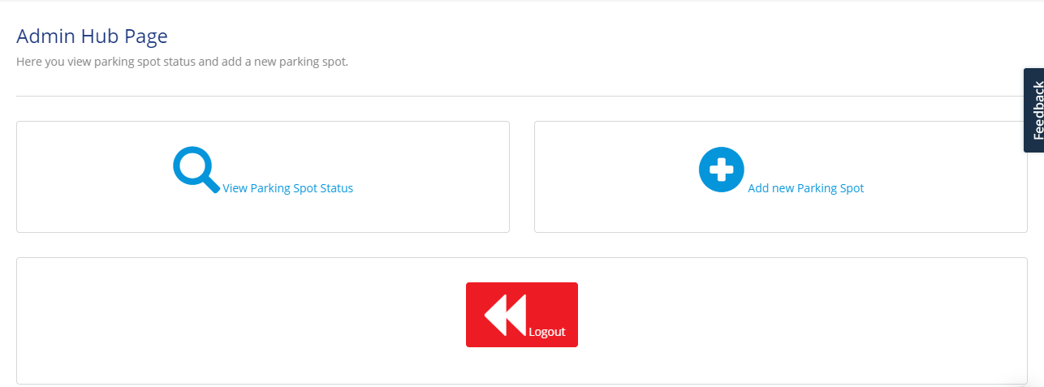

Screenshot 09--Admin add parking space

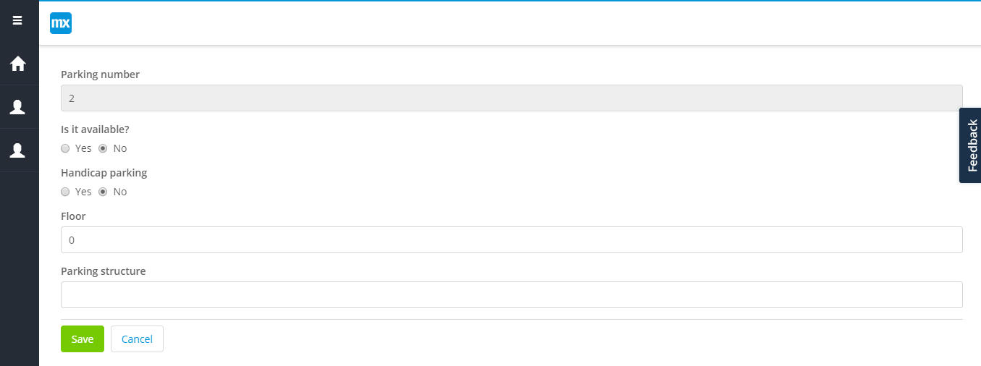

Screenshot 10--Admin parking space view (need to add data)

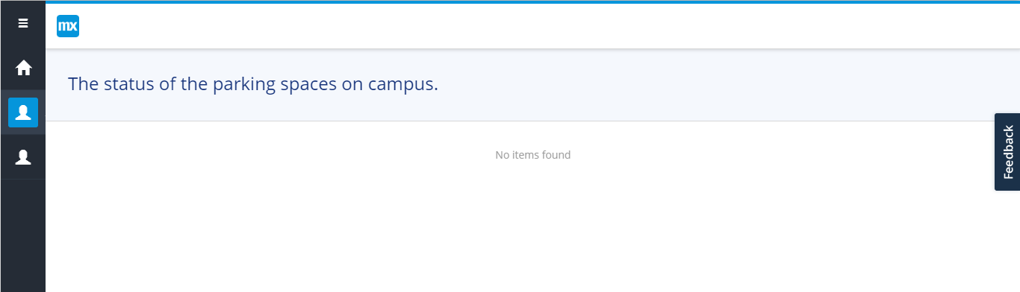

Screenshot 11--The database of the app

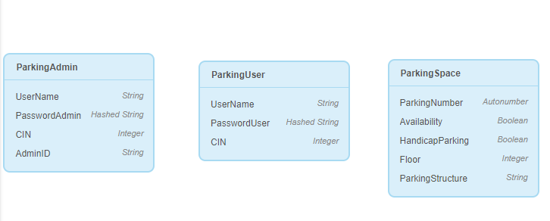

Technological Migration Plan and design

**C.** **TECHNICAL AND DESIGN PLAN**

**A.** **Product Description**

Find A Spot mobile application is created for drivers and parking enforcement. This app is great for students who are having trouble locating a parking lot with a free parking space, so they can get to class or meeting on time. The software will also allow parking enforcement to monitor and regulate parking with real-time data. The user side of the mobile application features parking space reservation, and navigation. On the other hand, the objectives of the product are specifically: (1) to provide an innovative solution that will make parking faster and easier for drivers and will help increase income and customers of parking lot owners, and (2) to implement smart parking system on all parking lots using their mobile device and the mobile application.

**List of Features**

· **User**

**1.** **Registration**

Registration of the user is the first necessary step in order to use the mobile application. The user can register using their CIN number and school-issued email.

**2.** **Sign in**

The sign in feature asks for the user for their mobile username, password, and CIN to log in to their account. Registering an account is required before a user can sign in.

**3.** **Parking Space View**

The parking lot view feature gives the user the ability to choose between map view or list view of available parking spaces on campus. The map view shows a geographical view of available parking spots along with the following information: parking lot, and handicap availability. The list view also displays the same information but, in a list, and the user can filter the list by setting their preferences.

**4.** **Parking Space Information**

The parking lot information display a brief description of the parking spot. This can be seen by the user before they reserve a parking space

**5.** **Parking Space Occupation**

Once the user has chosen a parking lot, they can reserve a parking space then release when leaving.

**8.** **Reservation via GPS Navigation System**

Since navigation system of the mobile application can generate an estimated time of arrival, this feature allows automatic setting of time of arrival to their desired space. Moreover, the app will use GPS technology to recommend parking spaces that are near the user’s class.

**Parking Enforcement**

**1.** **Registration**

Registration of Parking Enforcement is needed before they can work the mobile application. Employees must register with their school-issued email address, CIN, and employee ID.

**2.** **Sign in**

The sign in feature asks for employees for their mobile username, password, CIN, and employee ID to log in to their account. Registering an account is required before sign in.

**3.** **Parking Space View**

The parking lot view feature gives parking enforcement a list view of available parking spaces on campus. The list view also displays all the parking spots with there current status. The list view will provide parking enforcement with the information needed to better regulate the availability of parking.

**Application**

**1.** **Database**

User/employee sign information, and parking spot data will be stored in a secure database. Moreover, the data is simple to use, so parking enforcement can edit and delete data.